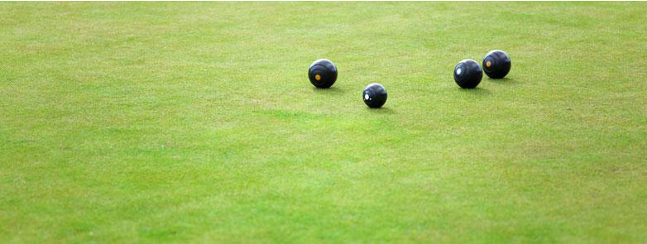
Club Support

Facebook Guide

This guide acts as a resource for bowls clubs on how to use Facebook and how to tailor their Facebook use to increase their awareness within their particular community.

If you are reading this and have never used Facebook before, feel free to begin reading from the basic level – this will give an insight in how to post on Facebook, choose a profile picture and lead you through things that are specific for starting to administer your club’s page.

If you’ve had some experience with Facebook previously, but have not yet managed a page or an organisation’s account on Facebook, start at the basic level too. This will help create your club’s webpage and teach skills such as sharing information from State and Territory Bowls Associations and Bowls Australia, customizing your Facebook page to suit your club and also how to give access to administrators and editors of your club’s page.

If your Facebook skills are more advanced and you have managed a page previously, visit the advanced section of this guide to learn how to advertise your club as well as setting your Facebook up to promote your club’s event.
Introductory Level – Facebook
How to select a page
category?

• Begin by clicking on the top right drop
down arrow and create a page
• Select your page category by clicking
on “local business or place” (like the
picture above)
• Then add your details in as per the
picture above

IMPORTANT – Make sure, if creating a
club Facebook page, that you see the
picture above. Many clubs mistakenly
set their Facebook up as a ‘person’
when they should be setting up their
Facebook as a ‘page’.

How to choose a profile
picture? (Using a logo) & How
to choose a cover photo?
Click on the Camera icon (in front of
background) to change cover photo
– this will be a blank photo when you
begin your page

• Click update profile picture in order
to change your profile picture (you
will need to hover your mouse over
the profile picture to get this option)
– it’s the camera icon near the Bowls
SA logo in this example (this will
also be blank)
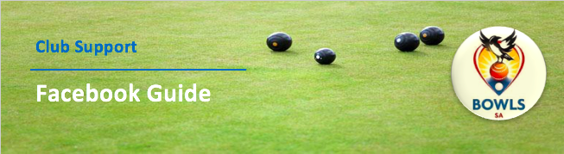

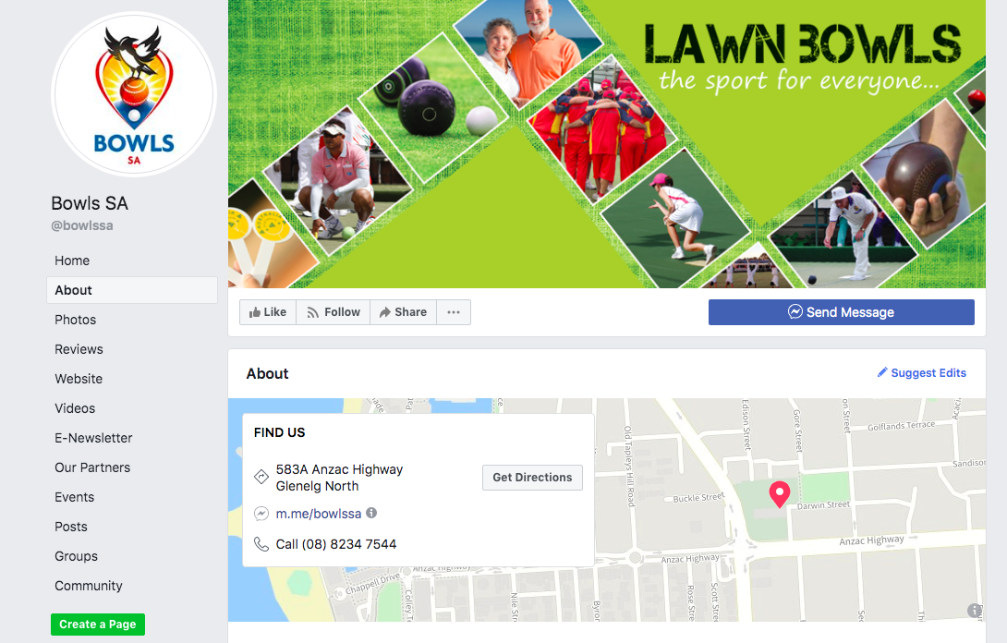
Adding a description
& website?
This can be done at the very beginning.
When people look at your Facebook
page, they will be able to see a map of
where you are located, with address/
phone number/opening hours and
website in the about section.

• This can be added by simply filling in
the prompted information (Facebook
will prompt you)

• It is important to know that if you reply
quickly to messages, Facebook
rewards you by showing on your page
that you reply to your members “within
a few hours” - (In other words, that
your club has good customer service
etc.)

Sharing Information:
• To share a piece of information on
Facebook with your members, click
share on any post you see to send it
straight to your Facebook page

• Once you click share, hit the “share...”
button and then share the information
as your club, to your club’s page

• This could be anything from Bowls
SA, Bowls Australia or local
news outlets that are relevant to your
Bowling club

Adding your club to your
favourites:
• Adding your club’s page to your
favorites makes it easily accessible
to find your club’s page on your own
personal Facebook. You can do this
by entering your managed pages on
the left hand side and clicking on the
little circle to the left of the page, then
you’re able to click ‘add to favourites’

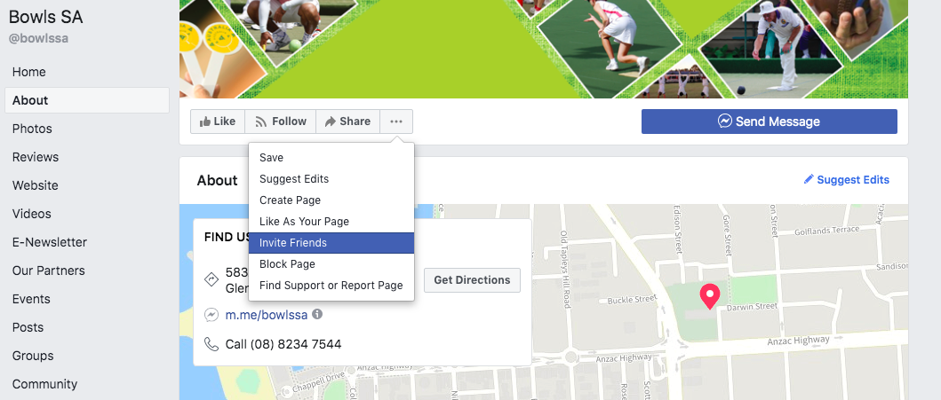
Inviting your friends to like
the page
• To invite your personal friends to your
club’s Facebook page, simply click
on invite friends (it’s on the drop down
menu with the three dots as you see
below)

• As discussed in other areas of this
document, you should invite as
many people who you think would be
interested in your club, and then get
those friends to invite their friends!

Creating Call to Action Button
• This button can either be a video, shop
or contact button for your Facebook
viewers to further get in touch with
the club and to find out some more
information. (Eg: Your point of call to
connect with you club)

• The previous picture shows a Bowls
SA call to action button which is a
‘contact us’ button. By clicking on this
button, a visitor to the page can be
directed to a page that connects them
to Bowls SA – you can do the
same with your club!

Uploading Photos, Photo
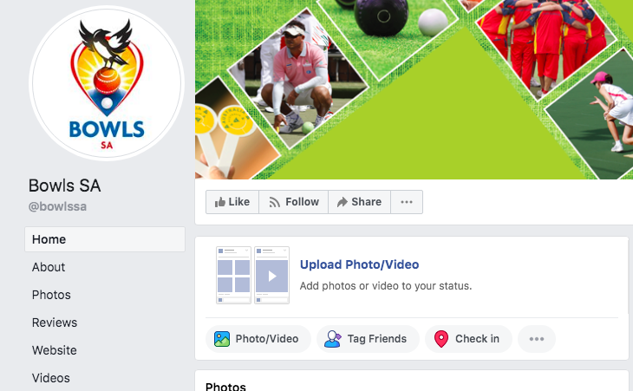
Albums & videos on your
Facebook page:
• To add a photo or video, click on the
photo/video tab next to ‘status’

• If you want to, Add the location when
you upload your photo or video to
further promote your club

• If looking to view the photos on your
page, click the Photos tab on the
home page to see your photos (it’s
halfway down on the left)

• As you can see below, there’s an
option to upload photo albums and
slideshows too!

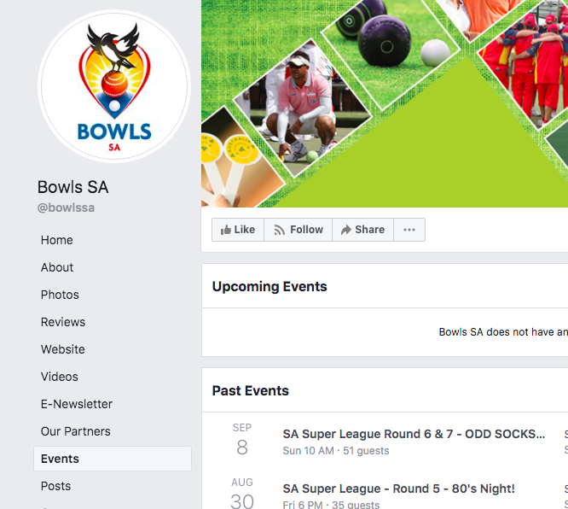

Creating an event (eg: Jack
Attack)
Whether it’s a club function, a new
Jack Attack program or Pennant
Competitions, you should do your best
as a club Facebook administrator to
highlight all events to your Facebook
community.

To begin this process, go to your Club
page and click the “Offer, Event” section
that you see below, then click event.
After this, you’ll be able to fill in the
details of your event (see below). This
involves adding dates, times, photos,
descriptions and links to your event.
Additionally, you’ll be able to invite
people to the event and promote it
through your personal Facebook page
as well as your club’s Facebook page.

Custom Web Address
It’s important to customize your
Facebook address so it’s easier for
people to read and find your club. This
would help on all promotional material,
brochures and flyers that your club
sends out to members. For example,
Bowls SA’s Facebook page can
be reached at: www.facebook.com/
bowlsSA.

Interacting with Local
Community Groups
More of this will be discussed in the
advanced level, but there are many
ways that a Facebook page can
connect with local community groups
around your bowls club. Some of these
ways include your page ‘liking’ the
groups around the area eg: Seymour
Bowling Club Facebook page ‘liking’
the Seymour Telegraph Newspaper
Facebook page.

Additionally, as your club Facebook
administrator, you are able to ‘tag’
accounts and direct a particular
Facebook page to your post by
advertising to them. It’s through a
click of a button and doesn’t cost the
club a cent! As mentioned, this will
be explained in further detail in the
advanced section.

Adding Admins/Editors of your club’s page
Difference between Editors and Admins

• Admins: Admins can manage all aspects of your club’s Facebook Page including sending messages and
publishing as the Page, creating ads, seeing which admin created a post or comment, viewing insights and
assigning various Facebook Page roles. (The Facebook Page Manager)

• Editors: Editors can edit the Page, send messages and publish as the Page, create ads, see which admin created
a post or comment, and view insights. (The Facebook Page Coordinator)
• Only admins can manage your club’s Facebook page roles and who has access to your Club’s Facebook Page

NOTE: It’s recommended that a Club Facebook page should have 3 administrators.
• One being someone with committee authority at the club,
• One being someone involved with the grassroots/development/pennant competition and;
• One who has access to the committee, or is responsible for club communications officer (CCO).

Advanced Level - Facebook
Tagging Accounts
A really important way of engaging
people around your community on
Facebook is to tag them in upcoming
events or posts where they need to see
the information.

To tag an account simply type the ‘@’
symbol before typing the name of the
organization. If you are successful in
tagging an account, the name of the
organization that you have tagged will
turn blue.

In the below example, Seymour Bowling
Club has used the tagging method to
show that they are now on Facebook.
As you can see, they have tagged the
Seymour Telegraph (Local Newspaper)
and St.Mary’s College Seymour (Local
School in the area).

In the other example, they have let
Seymour VRI Bowling Club (Another Club
in the area) know that Seymour is running
an Introductory coaching course on the
23rd of March by tagging them in their
event post.

This is a great way to engage community
groups but also sponsors. Sponsors who
might see this information and share it
across to their Facebook followers.

But how do you know if the particular
sponsor or group is on Facebook?
Good question.

If we take Seymour Bowling Club for
example, and they wanted to connect
with the local football club.

They would simply head to the search bar
on Facebook and type “Seymour Football
Club” in (like shown right).

Notice in this example right that Seymour
Football Club has been typed and there
are multiple options. To find the right
option, click the bottom section that says
“See all results for Seymour football club”.

For this example, After doing this,
Seymour would find the correct page.
The local Shepparton News pops up,
posting about the Seymour Football
Netball Club (written in blue). Eg:
Tagged.

Click on this link and it gives you this
page:

The picture shown here has the Seymour
Football Netball club logo, people
interacting with the post, people liking
the page and updated information – this
is when you know you have tagged the
right page.

After tagging them, then Facebook will
know for next time and this process will
become much easier!

Liking Pages as Your Club:
As you go into your personal Facebook,
head to the top right hand side of the
page. You will find a drop down menu
where it says you can use Facebook as
(your club’s page).

Using Facebook as your club is an
important factor when connecting with
local clubs, groups and other bowling
clubs.

When you are using Facebook as
your club, go in and ‘like’ all your local
sponsors and groups that support your
club. The reason you do this is to not
only help your members increase their
community, but as you can see in the
below picture, you are able to showcase
these groups on your Club’s page too.

Adding Sponsors to the page
As part of sponsorship packages, mentioning a brand or group a certain amount of times on Facebook each month
could be an extra element to a sponsorship deal. Remember you’re your members and the wider community who like
your page can see what you post, which means your club now has the advantage to highlight your sponsors using
your Facebook Page.

Analytics
As a club, the insights tab on your Facebook page will soon become your best friend. As the below picture shows, in
the sub menu you are able to see:

• How many likes (followers) on Facebook that your club has accumulated in a certain period of time
• How many people your club has reached on Facebook in a given post
• How many Video Views you’ve received from a certain post
• & from the people who have liked your page:
• What area they have come from?
• % of people liking your club’s page that are male/female, how many are in a certain age bracket
• Even the amount of people that have reached your Facebook page by coming off your club’s website!

What to do for major events?
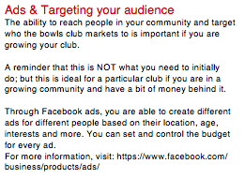
• Design a cover photo to highlight the particular event
• Highlight the event on your page by copying and
pasting the URL (website address of the event)
• Promote through word of mouth that there is a
Facebook event, get more people to join
• Invite all people that like your page by sending them a
Facebook message and then invite more people from
the local community
• After that, get those people to invite their friends!

Example:
• As a simple guideline, highlight the event once on
Facebook 4 weeks out, once with three weeks to go
and when there is two weeks to go – have four posts in
the lead up to the event
• Tagging various Facebook accounts that relate to local
news and involve local club Facebook Pages
• If it’s your club’s biggest event on the calendar, spend
a couple of $ on advertising it through Facebook. You
can spend this money targeting people around your
area and even tailor to certain demographics

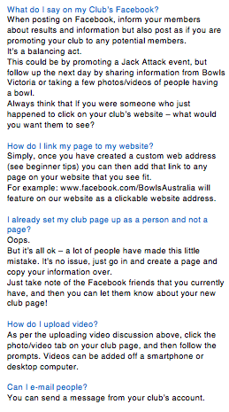
Frequently Asked Questions
Is it free to Use?
Yes, it’s free and does not cost your club anything.

How safe is my Facebook page?
Extremely. Just remember to limit password access
to your personal Facebook and only limit access to
your club’s page to key people in the club (2-3 as
recommended by BV).

Do you need any special training?
No special training. Follow the guide that Facebook
gives you & follow the guide that we’ve given you,
couple these two things with our top tips for using
Facebook and you will be fine!

Can I use Facebook on My Phone or Tablet?
Of course! Simply download the Facebook ‘app’ from
the app store – use this link to get you started: https://
itunes.apple.com/au/app/facebook/id284882215?mt=8

Can more than 1 person use Facebook?
Yes, this means that you are able to give access to
multiple people involved in your club. (But not too
many!!)

How does it help my club?
Facebook:
• Promotes your club to your local community
• Assists in promoting great achievements within your
club
• Updates club information to members
• Let’s your club promote its sponsors and partners
• Creates upcoming events that you can share with your
members
• Gives an extra platform for members to communicate
with one another

How do I connect to existing club members?
Easy. Invite 5 people to the page that are involved with
your club, then ask those 5 people to invite 5 others. All
of a sudden you might have 50 people connected to
your page!
Additionally, post flyers around the club and let people
know that you are on Facebook.

How do I connect to non-club members?
Simply tell people around the club to invite their friends.
Invite them to an event through your Facebook page, or
through word of mouth. Also continue tagging groups
around the community or sporting clubs. You never
know who will see your information and sign-up as a
result!

How do I add people as friends?
There are 3 dots on the right hand side of your page, hit
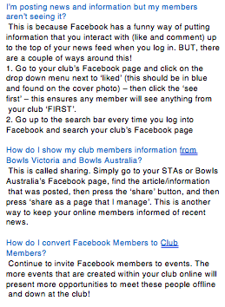
that button and press invite friends, then you’re able to
invite as many people as you want.
It’s great to get everyone inviting their friends, as many
people will be friends with different people from the club
on Facebook!

How often should I write a post?
You should aim to post every couple of days on your
page, but no more than 2-3 times per day.

How should I filter out inappropriate content?
If someone has made an inappropriate comment, hover
the mouse to the top right hand side of the comment,
there should be an X button. Pressing this will delete the
comment from the page. If there are repeat offenders
posting inappropriate comments, there is a button to
block certain people from your page, this is located in
the page settings tab.

Who should have access to the club Facebook page?
Approximately 2-3 people at the club, it’s advised that
one of these people helps out at a competition level at
your club (or is playing), one is involved at board level,
and one person who is responsible for communications.
If you are a smaller club, have a small amount of people
in charge, if you are a larger club, have 6-8 people
involved.
But the key to having multiple people on the one page
is to communicate with each other! A large amount of
information can get lost in translation if you are posting
frequently on your page!

How do I create and promote an event?
Creating an event involves going to the events tab and
clicking create an event. After this, you’ll be able to fill
out information about your event. After this, head up to
the top to the website address, right click and press
copy link. Then you are able to post this website address
on your Facebook page (where it says post) as many
times as you like!

How do I log onto my Club Facebook?
If you are granted access to an admin or editor position
for your club, you will automatically have access every
time you log into your personal Facebook account. To
use Facebook as your club, head to the top right drop
down menu on Facebook, then click on your club.
Alternatively, if you have selected your club’s page as a
favourite – then it will be on the left hand side when you
start using Facebook.

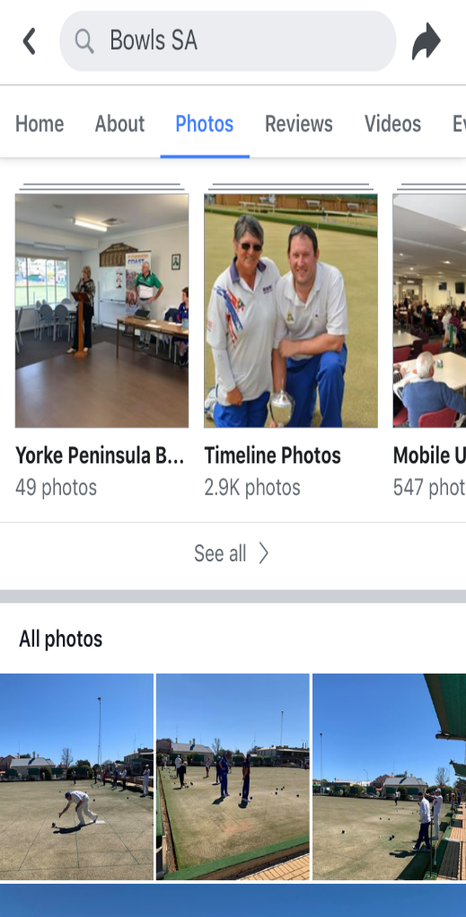
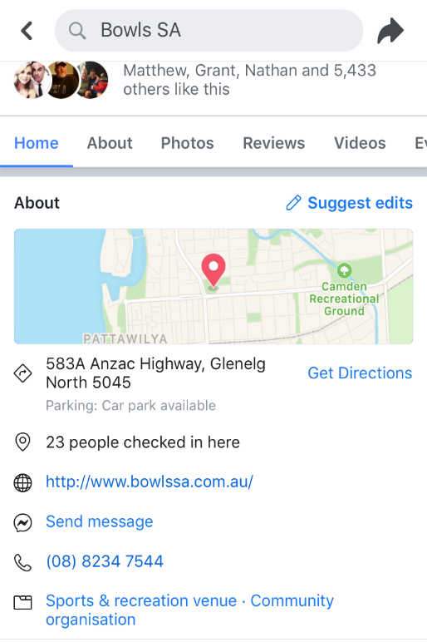
How to use Facebook on your
mobile or tablet
Using your smartphone or tablet is
similar to your desktop version of
Facebook in posting updates, adding
photos and events. However, these
areas might be switched around a little
bit compared to what you are used to.
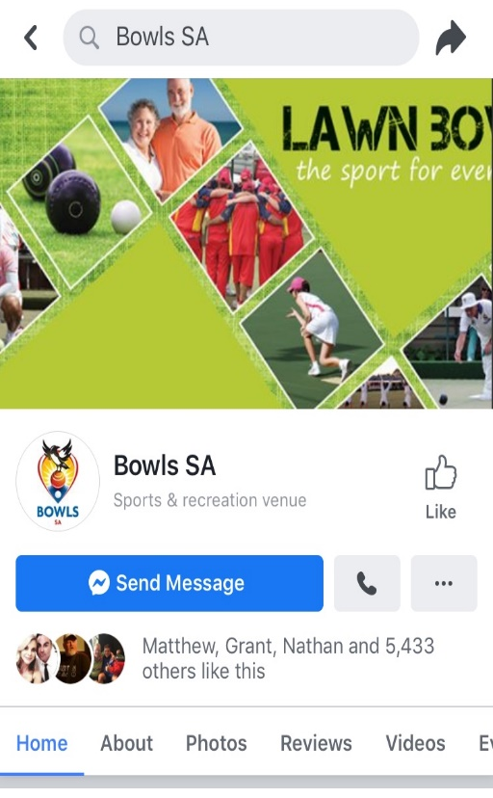

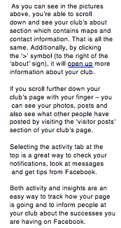

The above picture is what you should
expect when looking at your Club’s
Facebook page on the mobile version of
Facebook. As you can see, the options
to post, add a photo, promote your page
and check your notifications are not too
difficult to find at all. To find your page,
all you have to do is head to the “more”
button at the bottom right of your screen.

It’s the same as if using the computer
version of Facebook, click the camera
on your profile picture to change your
profile picture, or if changing your cover
photo up the top, click the cover photo
and select upload photo.

If you want to change settings on your
Facebook page via your mobile, simply
click the ‘more’ button on the homepage.
From this point, you’ll be able to click
and edit your settings and change
anything that you would normally be able
to from the desktop version of Facebook.

https://itunes.apple.com/au/app/
facebook/id284882215?mt=8

Attached is the link to the Facebook
App, where the above mobile
screenshots are from. The Facebook
App is easy to use and log in, just like
the desktop computer version.

