**Moonta Memorial Park Bowling Club Inc.**

2 Day Ian Hatcher's

Mens Medley

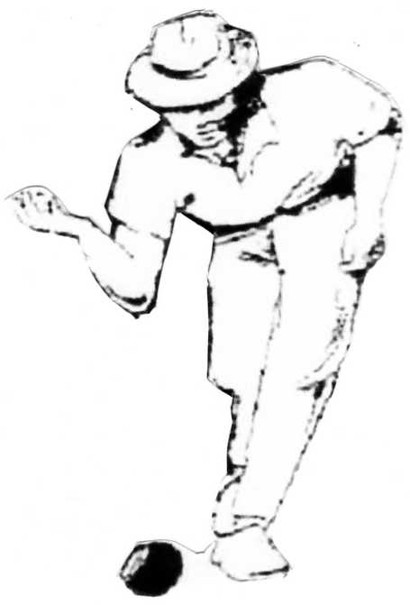***Saturday 27th & Sunday 28th March 2021***



**You are cordially invited to form a team for our**

***2 x 1 day Bowling Carnival***

***(Play one day or play both days)***

**PRIZES FOR EACH INDIVIDUAL DAY**

**EXTRA PRIZES FOR TWO DAYS**

**MEN’S FOURS MEDLEY**

**2 x 13 ends Fours, 2 x 10 ends 3 Bowl Pairs**

***Cost - $100 per team per day***

**This will include morning tea, lunch & afternoon tea on both days.**

**Wines from Cellarbrations Wallaroo**

**Play commences –**

**Saturday 9.30am - Sunday 9.00am**

**Points for single days & accumulated over the two days*[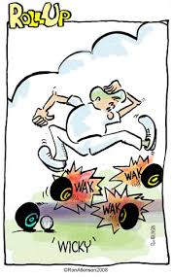](http://www.google.com.au/imgres?q=lawn+bowls&start=241&um=1&hl=en&sa=N&rlz=1W1ADRA_enAU404&biw=1440&bih=773&tbm=isch&tbnid=rXbQKCckMHprAM:&imgrefurl=http://ronatkinson.wordpress.com/category/lawn-bowls/page/7/&docid=SkZ8LAl3dThLJM&imgurl=http://ronatkinson.files.wordpress.com/2008/04/wicky.jpg?w%3D450&w=306&h=494&ei=SqkfT73PMYKciAeA-4XLDQ&zoom=1&chk=sbg)***

***Prizes to the value of $3,000***

**Lion Nathan**

**Royal Hotel**

**First National Real Estate**

**D & J Bennett Plumbers**

**Moonta Newsagency**

**Spiderman YP**

Wardle’s Garbage Conractors

YP Massage Therapy

**C:\Documents and Settings\Allan\My Documents\My Pictures\beer barrels.WMF*Replies to***

**Gordon Davis 0401 082160**

**Email: *davconaus@bigpond.com***

**PO Box 1046, MOONTA 5558**

***Entries close:***

***March 19th 2021***

**ENTRY FORM BELOW…………. You will be accepted in order of “first in” BUT all names of your Team must be filled in, and you are all to play in that order.**

**(Preference to the teams entering for both days)**

**FIRST 32 TEAMS ENTERED EACH DAY**

**“2 DAY IAN HATCHER’S MENS MEDLEY”**

**Conditions of Play .............. 27th & 28th March 2021**

**You Must be Entered for that day**

* **Entry Fee $100 per Team per Day**
* **Teams Positions as Entered ...Not to be changed**

**SATURDAY.... 27th. *(9.30am START)***

**a.m. 13 Ends of Fours**

**a.m. 10 ends of Pairs Skipper & Leader**

**p.m. 10 ends of Pairs Third & Second**

**p.m. 13 ends of Fours**

**Lunch for Third & Second while the other pair play then**

**Lunch for Skipper & Leader while the other pair play**

**SUNDAY.....28th. *(9.00am START)***

**a.m. 13 ends of Fours**

**a.m. 10 ends of Pairs Third & Leader (leader to skip)**

**p.m. 10 ends of Pairs Skipper & Second (second to skip)**

**p.m. 13 ends of Fours**

**Lunch for Skipper & Second while the other pair play then**

**Lunch for Third & Leader while the other pair play**

**NO DEAD ENDS:**

**JACK TO BE RESPOTTED ON THE CENTRE 2** 1st, 2nd, & 3rd Prize each day

**METRE MARK**

**SCORING: 1st, 2nd, & 3rd Prize for teams**

**20 pts a win playing both days**

**10 pts a draw**

**1 pt for each end won**

**C:\Users\Client\AppData\Local\Microsoft\Windows\Temporary Internet Files\Content.IE5\L0WWWPW7\MC900036714[1].wmf**

***Entry Form.....*Club........................................**

**Phone …………………… Mobile………………..**

**Email………………………………………………..**

***Name your Team***

**Skipper...........................................................**

**Third...............................................................**

**Second...................................................... …**

**Lead……………………………………………..please circle (yes or no) on what days you are playing**

**PLAYING SATURDAY 27th yes / no PLAYING SUNDAY 28th yes / no**